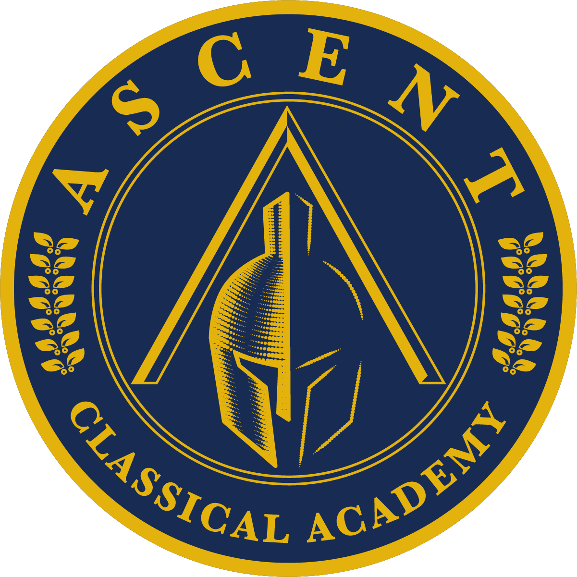
Ascent Classical Academy of Douglas County

12th Grade Summer Thesis Assignment

Senior Thesis Summer Assignment: Preliminary Proposal
Due: Thursday, August 21, 2025

The proposal does not need to be perfect or brilliant, nor is it final and permanent. The purpose of this assignment is to return in the fall with ideas on paper, so you have ideas to work with and refine when you start the course.

To prepare your Senior Thesis summer assignment, please complete the following:

- Read the Senior Thesis Handbook, attending particularly to the Thesis prompt and requirements.

- Reflect on the works and topics from your classical education that intrigue you.

  - The Thesis is not limited to only literary or historical works. Consider the full curricula of your education including the sciences, mathematics, languages, philosophy, physical education, and the arts. Consider especially how topics, questions, and works within these fields are related to the prompt and can help answer questions presented there. Please reach out to your Senior Thesis instructor and former teachers if you would like additional guidance with considering these topics.

  - You also do not necessarily need to choose a work or idea that you fully understand. The Senior Thesis is an excellent opportunity to explore topics that are challenging and raise questions.

  - The Senior Thesis is not a research paper nor is it a current issues paper. If you want to address a contemporary topic, you will need to discuss your ideas with the Thesis instructor and/or your advisor. For this assignment, focus first on identifying a possible work or works from the Western tradition that will be the centerpiece of your project.

  - During your reflection, you may also engage in some freewriting exercises to brainstorm ideas. See the prewriting exercises handout in the summer assignment folder for specific exercises you can try.

- Select a work you think you would like to study for your Senior Thesis.

  - Remember, you will be marinating in this work for nearly a year, so choose something that you are passionate about.

  - If you are fairly certain you would like to study this work for your Thesis, take some time to study the work again and make notes about what you notice and what questions the work prompts you to ask.

- Now, write a preliminary proposal in which you describe your selected topic and work, and articulate your research question.

  - Your proposal should ….
    - Articulate which work you want to choose and why;
    - Articulate why the work is important
    - Describe why the work interests you
    - A possible working research question raised by the work or major topic related to the work. You can reflect on more than one possible question or topic, if you want.
    - How this topic relates to human nature, the natural order, or the good*
    - Be at least 500 words in length (but no more than 1,000 words)
    - Be typed, following the ACA Style Guide.
    - Be clear and concise; clear thinking leads to clear writing.

*The Thesis prompt asks students to discuss what the work teaches about human nature or the good or natural order. Math and science often deal with questions about natural order, whereas the humanities often deals with questions of human nature.

*Topics of the natural order could raise questions such as “What do geometric proofs reveal about the nature of truth?” and “How does math describe human perception of beauty and harmony?” and “How do biological forms suggest their functions and what do these forms demonstrate about the natural ordering of life?”.

*Topics of human nature could raise questions such as “What does it mean to be human?”, “How should humans live best?”, “What are experiences common to humans (i.e. war, suffering, childhood, etc.) and how should we endure them?” and “What makes humans both noble (such as the ability to sacrifice or serve others) or depraved (such as the ability to wrong others)?”

The structure of the proposal is your decision. You may use first person references but do so judiciously and appropriately. Lastly, you are not “married” to your proposal. You may find, during the early stages of your project, that you amend your original plan.

