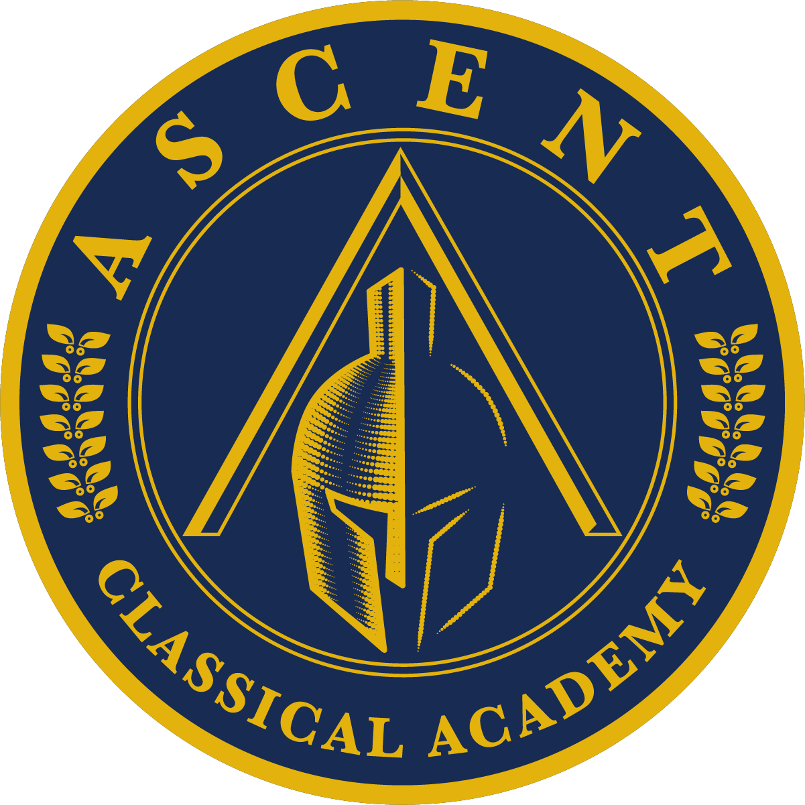
Ascent Classical Academy of Douglas County

12th Grade Summer Thesis Guidelines

Welcome to your final year as our sixth graduating class of Ascent Classical Academy. During this year, you will complete the capstone of your classical education: the Senior Thesis. The Thesis is an academic paper based on a topic and work of your choice, whose argument and significance you will articulate and defend before a panel.

As a culmination of your learning, the Thesis is a final opportunity to reflect on the wisdom and practice the skills that your education has fostered: close reading, logical writing, and clear speaking. Rather than a research project, the Thesis is a self-directed exploration of something old, significant, and worthwhile -- and something you deeply care about. The Thesis will also prepare you for your journey beyond graduation -- in college, the workplace, in your communities, and in our American society. It will be a landmark accomplishment, and meeting its challenge will make its completion all the more rewarding.

This course will contain a moral philosophy component. You will engage in questions of human nature and the good life, providing you context and a firm foundation from which to examine your work. This component will also help stretch your mind to find cogent refutations of your Thesis. Finally, the philosophical process you engage in will deepen and extend your analytical tools for wrestling with the questions your chosen work presents.

You will have many resources and support to help you fulfill the Senior Thesis requirement successfully. Firstly, your Senior Thesis instructor will equip you with the skills you need to write and defend your thesis. The Thesis has been down into incremental assignments and due dates to help you stay on track. You will have ample class time to work on these assignments and receive feedback. Secondly, once you have chosen your topic, you will select a thesis advisor among our Ascent faculty and staff. This advisor will work with you more closely on the particulars of your topic and text, provide the main feedback on your drafts, and serve on your defense panel in the fourth quarter. Finally, remember, you are ready for the Senior Thesis! Under the careful direction of our faculty and staff, you have been training your mind, body, and heart each day of your education to achieve this capstone. You are knowledgeable, skilled, articulate, virtuous, and passionate. Already, you bring these qualities to this project, and you have our whole community here to support you and encourage you and celebrate you through the process.

Attached to this letter is the Thesis prompt and timeline overview. For more details, including sample works lists, please consult the Senior Thesis Handbook. You may, of course, choose a work not included in this list or in the Ascent curriculum, but you will need to receive approval from your Thesis instructor before you move forward with that work. Also, you are not limited to written texts; you may consider, for example, artistic, dramatic, or musical works, historical events, and quantitative or scientific works for your project.

This summer, please reflect on which work(s) and topic(s) you might want to engage with for your Thesis. In these early stages, you may prewrite ideas to help you brainstorm and discern which topics interest you the most. Then, write a typed preliminary proposal which you will turn in on Thursday, August 21, 2025. During the first few days of school, we will discuss the Thesis Handbook, the prompt, expectations, timeline, and any other questions you might have before delving into the project.

Please email any questions about Senior Thesis to aaron.southwick@dc.ascent.colorado.org.

Here’s to a challenging and rewarding year together. Congratulations, Class of 2026!

Senior Thesis Prompt

Choose one work (or author, artist, composer, scientist, thinker, etc.) and explain what it (he/she) teaches about human nature, the human good, and/or the natural order. You may also examine this work for what it teaches about the good, true, and/or beautiful.

Senior Thesis Timeline *

August &  September | Submit preliminary proposal  Study work and formulate research question  Collect evidence  Select advisor
October | Formulate working thesis statement  Submit final proposal
November | Outline  Refine thesis statement
December | Outline with evidence
January | Draft 1
February | Draft 2 with revisions
March | Draft 3 with revisions
April | Final draft for defense panel  Prepare for defense
May | Thesis Defenses  Final draft with changes from defense  Senior Banquet with Thesis Recognition

*Timeline is subject to change at the discretion of the instructors.

